## 

## 

## **Bradley Culligan, E5**

## **IT PAT, Phase 1**

## **Slice ‘n Dice**

## **2018**

# 

# 

# Basic Design:

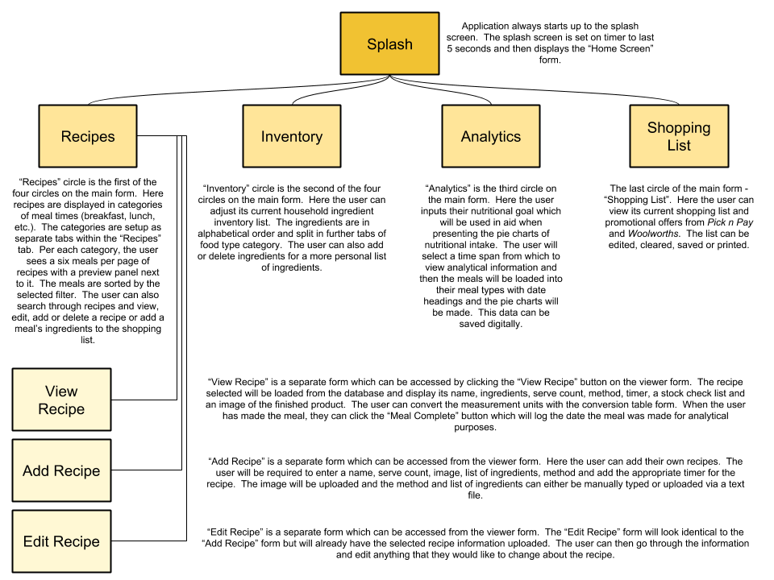

# Database Design:

|  |  |  |  |  |
| --- | --- | --- | --- | --- |
| **tblRecipe** | | | | |
| **FIELDS** | **DATA TYPE** | **SIZE** | **EXAMPLE** | **VALIDATION** |
| RecID | AutoNumber | Long integer | 2 | >0; numeric only |
| RecName | Short Text | 100 | Baked Cheesecake | Required; do not allow zero length |
| RecImage | Short Text | 255 | Cheesecake.jpg | Application adds file extension type |
| RecType | Short Text | 9 | Dessert | Required; application drop menu |
| RecServe | Number | Byte | 8 | Defaults to 0; application forces numeric value |
| RecMethod | Long Text | 64 000 | Preheat oven to 180°.  Crush biscuits in a food processor and mix with melted butter.  Line the base of 22cm cake tin with baking paper and place biscuit mix in the tin.  Press down the biscuit mix with a spoon and bake for 10 minutes.  Mix the cream cheese, eggs, sugar, flour, 250g creme fraiche plus two extra tablespoons of creme fraiche and vanilla extract in a bowl.  Pour into the baked base and bake for 15 minutes at 180°, then turn the oven down to 140° and bake for 50 minutes.  Turn off oven and allow cheesecake to cool in oven.  Refrigerate the cake for 1½ hours before you take it out the tin.  Top it with the extra creme fraiche and strawberries and dust with icing sugar. | Do not allow zero length |
| RecCookTime | Number | Integer | 140 | Default 0; application forces numeric value |
| RecTimer | Short Text | 3 | 10 | Default 0; do not allow zero length; application forces numeric value |

|  |  |  |  |  |
| --- | --- | --- | --- | --- |
| **tblIngredient** | | | | |
| **FIELDS** | **DATA TYPE** | **SIZE** | **EXAMPLE** | **VALIDATION** |
| IngID | AutoNumber | Long Integer | 12 | >0; numeric only |
| IngName | Short Text | 190 | Egg | Required; do not allow zero length |
| IngAvailable | Yes/No | Yes/No | Yes | Default No |
| IngType | Short Text | 20 | Dairy | Application forces a choice from drop menu |

|  |  |  |  |  |
| --- | --- | --- | --- | --- |
| **tblRecipeIngredientNeed** | | | | |
| **FIELDS** | **DATA TYPE** | **SIZE** | **EXAMPLE** | **VALIDATION** |
| RecIngNeedID | AutoNumber | Long Integer | 6 | >0; numeric only |
| RecID | Number | Long Integer | 1 | Connected to tblRecipe |
| RecIngNeedText | Short Text | 200 | 7 apples | Application |

|  |  |  |  |  |
| --- | --- | --- | --- | --- |
| **tblTrack** | | | | |
| **FIELDS** | **DATA TYPE** | **SIZE** | **EXAMPLE** | **VALIDATION** |
| TrackID | AutoNumber | Long Integer | 4 | >0; numeric only |
| TrackDate | Date/Time | Short Date | 2018/08/16 | Default current date; format yyyy/mm/dd |
| RecID | Number | Long Integer | 94 | Connected to tblRecipe |

|  |  |  |  |  |
| --- | --- | --- | --- | --- |
| **tblDietaryGoal** | | | | |
| **FIELDS** | **DATA TYPE** | **SIZE** | **EXAMPLE** | **VALIDATION** |
| DGoalID | AutoNumber | Long Integer | 4 | >0; numeric only |
| DGoalPercent | Number | Byte | 7 | Default 0; application forces numeric only |
| DGoalType | Short Text | 20 | Fruit and Vegetables | Uneditable by the user |

### Relationship:

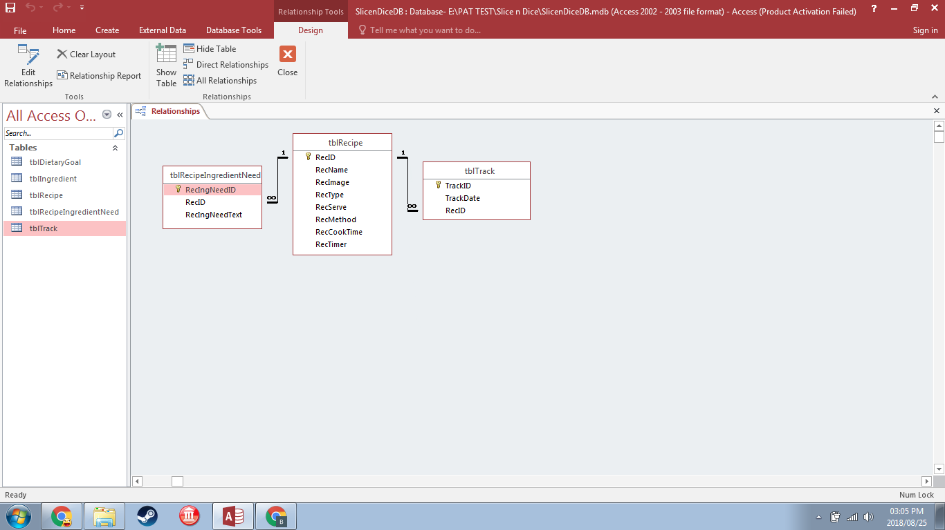

# Data Dictionary:

|  |  |  |  |
| --- | --- | --- | --- |
| **DATA STRUCTURE** | **NAME** | **DATA STORED** | **COMMENTS** |
| Arrays | CtrlState | Integer | DFCS_BUTTONCHECK, DFCS_BUTTONCHECK or DFCS_CHECKED which determines the checkbox style to be drawn in the dbGrids |
| arrKeys | String | 6 values which hold the RecIDs of the recipes that can be seen in the viewer |
| arrRecID | String | Contains the RecIDs of the recipes within the “to” and “from” dates |
| arrIngredients | String | Contains all ingredient text of all the ingredients that are needed for the appropriate RecIDs in arrRecID |
| arrTypeCount | Integer | Keeps count of the quantities of the various food types based on their quantity found in arrIngredients |
| arrColours | TColor | Colours to be used for the pie chart |
| arrLabels | String | Labels to be used for the pie chart |
| arrGoal | String | Contains all goal dietary values that the user can edit |
| Constants | Rect | TRect | Data about the rectangular parameters |
| DataCol | Integer | Data column |
| Column | TColumn | Appropriate column |
| State | TGridDrawState | The current draw state of the dbGrid |
| iSS | Integer | Remains 0 - value for seconds in the timer which is used in formatting the timer |
| Database | tblRecipe | Recipes | All information pertaining to recipes except for their ingredient text |
| tblRecipeIngredientNeed | Ingredient text for recipes | Ingredient text needed for recipes |
| tblIngredient | Inventory stock | List of all ingredients shown in the Inventory form of the application |
| tblTrack | Meal tracking | Dates of past meals for analytical data |
| tblDietaryGoal | Dietary goal values | Keeps track of the user’s dietary goal values |
| Object | objDependencies | TDependencies | Contains (as string):   * SelectedID * MealType * AddOREdit * FromDate * ToDate   These values are used to carry data across to other forms |
| Text files | tFile (Shopping List.txt) | Shopping list data | Text file stored in application folder which holds the data of the current shopping list. Items are added to this text file when the shopping list in the application is updated and is used to load the application shopping list when the user closes the application and reopens it at a later stage |
| tShopList (Shopping List yyyymmdd.txt) | Shopping list data | User’s own save of the shopping list for them to digitally store on their local hard drive or to upload to their online storage. yyyymmdd is replaced with the current date |
| tFile (sFile) | List of ingredient text needed for a recipe | User selects a text file with the ingredient data they want to upload and then the data is uploaded to the listbox |
| tAnalytics (Analytics yyyymmdd.txt) | File made by application to be saved for user based on analytical data | User’s save (in text file format) of the data shown in the analytical columns. yyyymmdd is replaced by current date |
| Variables | sDate | String | Current date in format yyyymmdd |
| sItem | String | Item to be added to shopping list |
| sQuantity | String | Quantity of item to be added to shopping list |
| sLine | String | Line of text from application shopping list to be written to text file shopping list or vice versa |
| iLineCounter | Integer | Used to get last two lines of text in the shopping list which gets added to the text file shopping list |
| FOriginalOptions | TDBGridOptions | Keeps the dbGrid’s original options so options can quickly be changed back to original options after options have changed for editing function |
| iImageCount | Integer | Used to count through the six images shown in the catalog of the viewer |
| iPage | Integer | Keeps track of the page number of the catalog part of the viewer |
| iRecordNumber | Integer | Number of records within a recipe type category which is used to limit loading recipes further than this number as this would cause an error |
| sID | String | The RecID of the currently loading recipe to add to arrKeys |
| sRecName | String | The recipe name of the selected recipe which is used in confirming with the user about deleting the recipe |
| sSearchedID | String | Sets the SelectedID in objDependencies based on what item was searched |
| sSearchText | String | The text that the search bar is using to search in the dbGrid below it |
| sImageField | String | The name of the file which pertains to the necessary image to be loaded |
| sName | String | Recipe name to be loaded |
| sServe | String | Serve count of recipe to be loaded |
| sTime | String | Total time of cooking to be displayed for the loaded recipe |
| dynLogoIMG | TImage | Dynamic variable used to load the logo image in place of the timer if no timer is required for a recipe upon viewing |
| bTimerActive | Boolean | Keeps track of whether the timer is active or not |
| iTime | Integer | Total timer value which is used to split into hour and minute values |
| bTimerNeeded | Boolean | Tracks whether a timer is needed or not to know if a timer or logo image must be displayed |
| iSelect | Integer | Used in confirming with the user whether they want to “go back” |
| iHH | Integer | Hour value entered by the user in resetting the timer |
| iMM | Integer | Minute value entered by the user in resetting the timer |
| iHH | Integer | Hour value based on splitting the iTime variable for the timer that is displayed to the user |
| iMM | Integer | Minute value based on splitting the iTime variable for the timer that is displayed to the user |
| sIng | String | Used to load the list of ingredients when viewing a recipe |
| iTimerSS | Integer | Used in updating the timer value shown to the user |
| iTimerMM | Integer | Used in updating the timer value shown to the user |
| iTimerHH | Integer | Used in updating the timer value shown to the user |
| bTimerDone | Boolean | Determines whether the timer is complete or still working its way down the set time |
| sIng | String | Used to load the list of ingredients when using the “Add Meal to Shopping List” pop up form |
| PieCharts | TPieCharts | Used to adjust the slices of the achieved pie chart |
| q | Integer | Counter used to add ingredients to arrIngredients |
| w | Integer | Counter to go through arrIngredients and add appropriate values to arrTypeCount |
| r | Integer | Counter to go through arrTypeCount and initialise the array |
| iCount | Integer | Counter used when adding data to the new series of the pie chart (achieved) |
| dynLogoIMG | TImage | Dynamic variable to create the image of the logo in the timer’s place for adding or editing a recipe |
| bImgChange | Boolean | Tracks whether the image for a recipe was changed or not so the application knows what statements to execute from there on |
| sIng | String | Contains the ingredient text of a recipe which the user is adding to the ingredient listbox |
| sFile | String | Name of text file from which the ingredients/method will be loaded into the application |
| iIngCount | Integer | Counter when going through the ingredient listbox to add data to the database |
| iWidth | Integer | Width of current item in ingredient listbox |
| iMaxWidth | Integer | Width of longest item in ingredient listbox |
| iItemCount | Integer | Counter when going through the ingredient listbox |
| jIngCount | Integer | Counter when going through the ingredient listbox |
| Bmp | TBitmap | Bitmap variable to assign the loaded image to from which the image will be saved |
| bSettingAllowed | Boolean | Allows or restricts ability of setting the “to” and “from” dates in the objDependencies to be used in the achieved pie chart |
| k | Integer | Counter used in updating database with dietary goal values entered by user |
| k | Integer | Counter used in updating array with dietary goal values from database |
| iTotal | Integer | Total value of dietary goal. This value must equal 100 to validate that the user has entered the values in percentage form |

# Input Process Output:

## Splash

### Slice_n_Dice_Splash_u - SnDSplash



|  |  |  |
| --- | --- | --- |
| **INPUT** | **PROCESS** | **OUTPUT** |
| User starts application | * Timer component is active while splash image is displayed * Timer runs down to zero | Splash screen closes and home screen is displayed for user to take further action |

|  |  |
| --- | --- |
| **CODE** | **EXPLANATION** |
| procedure TSnDSplash.splashTimerTimer(Sender: TObject);  begin  splashTimer.Enabled := false; // when timer is complete, close form to show home screen  close;  end; | When timer component is complete, close form and show home screen |

## Home Screen

### Slice_n_Dice_Home_u - SnDHome

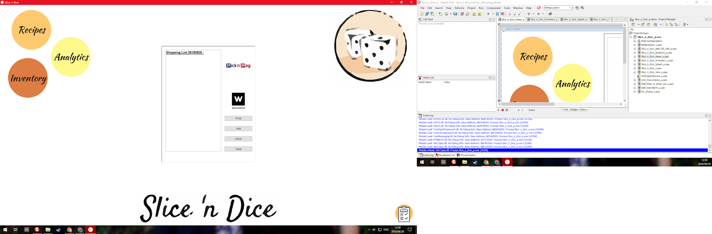

|  |  |  |
| --- | --- | --- |
| **INPUT** | **PROCESS** | **OUTPUT** |
| Mouse hover over “Recipes” circle | Background image is loaded with new image found in application folder | Top right corner image changes to match the theme of recipes |

|  |  |
| --- | --- |
| **CODE** | **EXPLANATION** |
| procedure TSnDHome.imgRecipesMouseEnter(Sender: TObject);  begin imgBackground.Picture.LoadFromFile('SnDHomeTwo.png');  end; | Load recipe image which is backing image |

|  |  |  |
| --- | --- | --- |
| **INPUT** | **PROCESS** | **OUTPUT** |
| Mouse hover over “Inventory” circle | Background image is loaded with new image found in application folder | Top right corner image changes to match the theme of inventory ingredients |

|  |  |
| --- | --- |
| **CODE** | **EXPLANATION** |
| procedure TSnDHome.imgInventoryMouseEnter(Sender: TObject);  begin imgBackground.Picture.LoadFromFile('SnDHomeThree.png');  end; | Load inventory image which is backing image |

|  |  |  |
| --- | --- | --- |
| **INPUT** | **PROCESS** | **OUTPUT** |
| Mouse hover over “Analytics” circle | Background image is loaded with new image found in application folder | Top right corner image changes to match the theme of analytics |

|  |  |
| --- | --- |
| **CODE** | **EXPLANATION** |
| procedure TSnDHome.imgAnalyticsMouseEnter(Sender: TObject);  begin  imgBackground.Picture.LoadFromFile('SnDHomeFour.png');  end; | Load analytics image which is backing image |

|  |  |  |
| --- | --- | --- |
| **INPUT** | **PROCESS** | **OUTPUT** |
| Mouse hover over circle with shopping list icon | Receives text hint | Text hint is displayed over icon |

|  |  |  |
| --- | --- | --- |
| **INPUT** | **PROCESS** | **OUTPUT** |
| User clicks shopping list icon | Application determines whether the shopping list is currently visible | If shopping list is visible - hide shopping list  If shopping list is invisible - show shopping list |

|  |  |
| --- | --- |
| **CODE** | **EXPLANATION** |
| procedure TSnDHome.imgShoppingListClick(Sender: TObject);  begin  if pnlShopList.Visible = false then  begin  pnlShopList.Visible := true;  end  else if pnlShopList.Visible = true then  begin  pnlShopList.Visible := false;  end;  end; | If shopping list is visible - hide shopping list  If shopping list is invisible - show shopping list |

|  |  |  |
| --- | --- | --- |
| **INPUT** | **PROCESS** | **OUTPUT** |
| User clicks *Pick n Pay* logo image | Application starts default internet browser and loads URL with set URL | Default internet browser is opened on the *Pick n Pay* promotions page |

|  |  |
| --- | --- |
| **CODE** | **EXPLANATION** |
| procedure TSnDHome.imgPicknPayClick(Sender: TObject);  begin  ShellExecute(0, 'open', 'https://www.pnp.co.za/welcome?rf=y&_ga=2.258583689.2005233561.1525418824-1984058615.1525418822', nil, nil, SW_ShowNormal);  end; | ShellAPI is required for the ShellExecute function which allows *Slice ‘n Dice* to open applications on the user’s computer |

|  |  |  |
| --- | --- | --- |
| **INPUT** | **PROCESS** | **OUTPUT** |
| User clicks *Woolworths* logo image | Application starts default internet browser and loads URL with set URL | Default internet browser is opened on the *Woolworths* promotions page |

|  |  |
| --- | --- |
| **CODE** | **EXPLANATION** |
| procedure TSnDHome.imgWoolworthsClick(Sender: TObject);  begin  ShellExecute(0, 'open', 'http://www.woolworths.co.za/store/cat/_/N-1z13sk5Z1ha6kkl', nil, nil,  SW_ShowNormal);  end; | ShellAPI is required for the ShellExecute function which allows *Slice ‘n Dice* to open applications on the user’s computer |

|  |  |  |
| --- | --- | --- |
| **INPUT** | **PROCESS** | **OUTPUT** |
| User clicks “Print” button | Print dialog is opened for user to execute print from | If executed, the shopping list will be printed to the printer; else the print will be cancelled and the dialog will close |

|  |  |
| --- | --- |
| **CODE** | **EXPLANATION** |
| procedure TSnDHome.btnPrintSLClick(Sender: TObject);  begin  if dlgPrint.Execute then  begin  Application.ProcessMessages;  redShopList.Print('Shopping List');  end;  end; | If the print dialog is executed, call the print function of the richedit containing the text to be printed |

|  |  |  |
| --- | --- | --- |
| **INPUT** | **PROCESS** | **OUTPUT** |
| User clicks “Add” button | Receives data from user pertaining to the ingredient name and quantity to be added to the shopping list | Shopping list in application is updated with newly added value and the text file shopping list also receives the updated value to keep the text file shopping list up to date with the most recent version of the shopping list |

|  |  |
| --- | --- |
| **CODE** | **EXPLANATION** |
| procedure TSnDHome.btnAddSLClick(Sender: TObject);  var  sItem, sQuantity, sLine: string;  tFile: TextFile;  iLineCounter: integer;  begin  sItem := InputBox('Add to shopping list',  'What ingredient would you like to add to your shopping list?', '');  // gets item from user  sQuantity := InputBox('Add to shopping list',  'How much of the ingredient do you need to buy?', '');  // gets quantity of item from user  redShopList.Lines.Add('');  redShopList.Lines.Add(sItem + #9 + sQuantity);  // adds item and quantity to shopping list  AssignFile(tFile, 'Shopping List.txt'); // assign shopping list textfile to variable  if fileexists('Shopping List.txt') = true then  begin  Append(tFile); // if shopping list textfile is present, go to end of textfile  end  else  Rewrite(tFile); // create new text file for shopping list  for iLineCounter := redShopList.Lines.Count downto redShopList.Lines.Count -  1 do // last line has most recently added item and line before that contains space for ease of readibility  begin  sLine := redShopList.Lines[iLineCounter];  Writeln(tFile, sLine); // writes these lines to the shopping list textfile so shopping list data is saved  end;  CloseFile(tFile);  end; | Receive item and quantity to add to shopping list. Adjust both the application and the text file shopping list with newly added value |

|  |  |  |
| --- | --- | --- |
| **INPUT** | **PROCESS** | **OUTPUT** |
| User clicks “Clear” button | Clears the shopping list richedit and text file contents and calls the Shop List Header procedure to add the heading | Clear richedit shopping list with dated heading on top |

|  |  |
| --- | --- |
| **CODE** | **EXPLANATION** |
| procedure TSnDHome.btnClearSLClick(Sender: TObject);  var  tFile: TextFile;  begin  redShopList.Clear;  ShopListHeader; // rewrites the shopping list heading to the richedit which is now empty  AssignFile(tFile, 'Shopping List.txt');  Rewrite(tFile); // Clears text file  CloseFile(tFile);  end;  ________________________________________  procedure TSnDHome.ShopListHeader;  var  sDate: string;  begin  sDate := FormatDateTime('yyyymmdd', Now); // saves current date to variable sDate in format 'yyyymmdd'  redShopList.Lines.Add('Shopping List ' + sDate + ' :'); // heading for shopping list which includes current date  redShopList.SelStart := 0;  redShopList.SelLength := 24; // selects heading text  redShopList.SelAttributes.Style := redShopList.SelAttributes.Style + [fsBold]  + [fsUnderline]; // makes heading text bold and underlined  end; | Clears richedit and text file. Calls ShopListHeader procedure  ________________________________________  Gets current date; adds date to “Shopping List” header text; sets header text to be bold and underlined on the richedit |

|  |  |  |
| --- | --- | --- |
| **INPUT** | **PROCESS** | **OUTPUT** |
| User clicks “Save” button | Save dialog is opened for user to execute. Text in richedit is added to text file to be saved | User has a saved text file in their local storage |

|  |  |
| --- | --- |
| **CODE** | **EXPLANATION** |
| procedure TSnDHome.btnSaveSLClick(Sender: TObject);  var  tShopList: TextFile;  sDate: string;  begin  dlgSaveTxtFileShopList.Filter := 'Text file|*.txt';  // filters save dialog to textfile formats  dlgSaveTxtFileShopList.DefaultExt := 'txt'; // automatically sets file to be saved's extension as .txt  sDate := FormatDateTime('yyyymmdd', Now); // gets current date, formatted  dlgSaveTxtFileShopList.FileName := 'Shopping List ' + sDate; // automatically sets textfiles name to be 'Shopping List' with the date afterwards  if dlgSaveTxtFileShopList.Execute then  begin  try  redShopList.PlainText := true; // sets shopping list to plaintext to be saved  AssignFile(tShopList, dlgSaveTxtFileShopList.FileName);  Rewrite(tShopList); // textfile made  Writeln(tShopList, redShopList.Text); // shopping list contents added to textfile  CloseFile(tShopList);  redShopList.PlainText := false; // set shopping list richedit back to formatted  ShowMessage('File has successfully been saved');  except  ShowMessage('File save was cancelled'); // tell user that shopping list save has been cancelled  end  end;  end; | Limits save dialog to .txt files only and automatically sets the file name to be “Shopping List yyyymmdd.txt” with yyyymmdd replaced by the current date. File is either saved by user or dialog is closed |

|  |  |  |
| --- | --- | --- |
| **INPUT** | **PROCESS** | **OUTPUT** |
| User clicks “Recipes” circle | Builds the appropriate form | Appropriate form is displayed |

|  |  |
| --- | --- |
| **CODE** | **EXPLANATION** |
| procedure TSnDHome.imgRecipesClick(Sender: TObject);  begin  ViewRecipe;  end;  ________________________________________  procedure TSnDHome.ViewRecipe;  begin  SnDRecipes := TSnDRecipes.Create(self); // Create the form  try  SnDRecipes.ShowModal; // Show the form  finally  SnDRecipes.Free; // Free the form from memory  end;  end; | Calls ViewRecipe procedure which creates the appropriate form in memory |

|  |  |  |
| --- | --- | --- |
| **INPUT** | **PROCESS** | **OUTPUT** |
| User clicks “Inventory” circle | Builds the appropriate form | Appropriate form is displayed |

|  |  |
| --- | --- |
| **CODE** | **EXPLANATION** |
| procedure TSnDHome.imgInventoryClick(Sender: TObject);  begin  ViewInventory;  End;  ________________________________________  procedure TSnDHome.ViewInventory;  begin  SnDInventory := TSnDInventory.Create(self);  try  SnDInventory.ShowModal;  finally  SnDInventory.Free;  end; | Calls ViewInventory procedure which creates the appropriate form in memory |

|  |  |  |
| --- | --- | --- |
| **INPUT** | **PROCESS** | **OUTPUT** |
| User clicks “Analytics” circle | Builds the appropriate form | Appropriate form is displayed |

|  |  |
| --- | --- |
| **CODE** | **EXPLANATION** |
| procedure TSnDHome.imgAnalyticsClick(Sender: TObject);  begin  ViewAnalytics;  End;  ________________________________________  procedure TSnDHome.ViewAnalytics;  begin  SnDAnalytics := TSnDAnalytics.Create(self);  try  SnDAnalytics.ShowModal;  finally  SnDAnalytics.Free;  end;  end; | Calls ViewAnalytics procedure which creates the appropriate form in memory |

## Recipe Viewer

### Slice_n_Dice_u - SnDRecipes

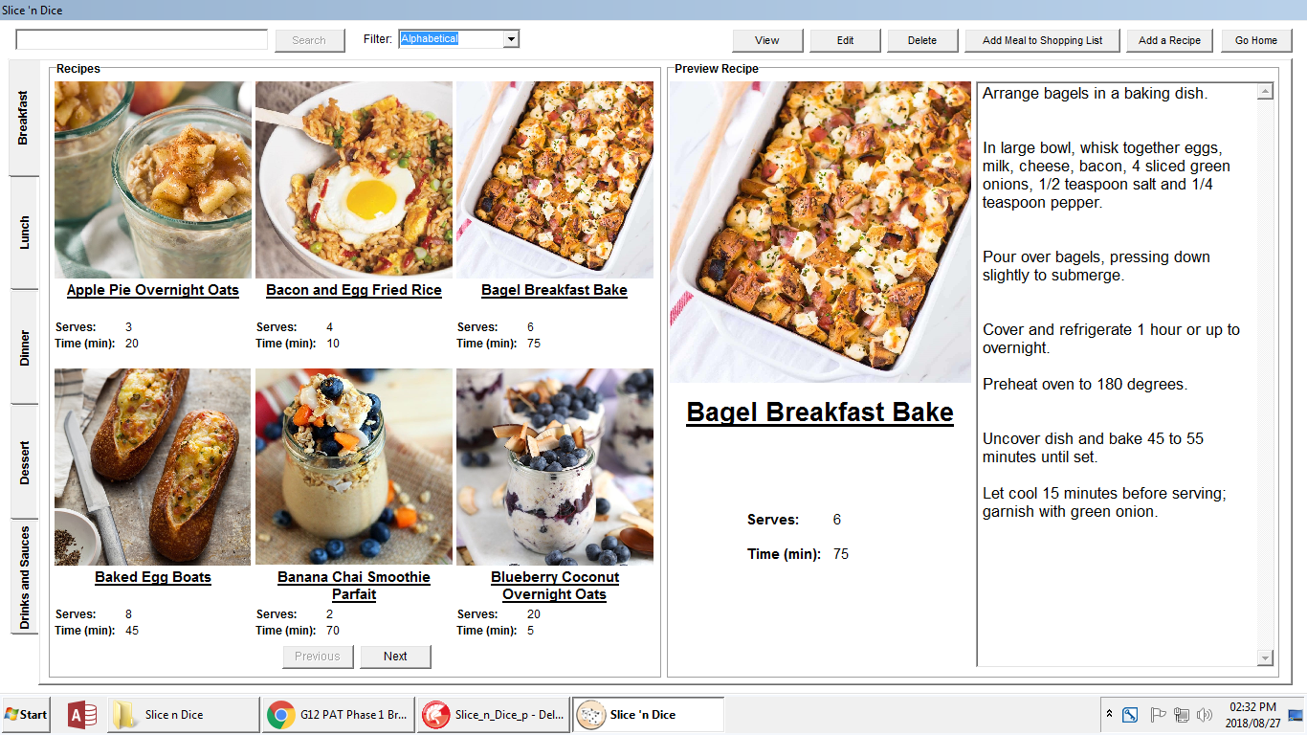

|  |  |  |
| --- | --- | --- |
| **INPUT** | **PROCESS** | **OUTPUT** |
| User selects tab of meal type | Database filter updates based on tab index | All recipes displayed are of the new filter type. Buttons become disabled because no recipe is selected and *Slice ‘n Dice* logo is displayed in the preview panel |

|  |  |
| --- | --- |
| **CODE** | **EXPLANATION** |
| procedure TSnDRecipes.tcRecipesChange(Sender: TObject);  begin  iPage := 0; // meal type change, therefore go to start of records  btnPrevious.Enabled := false;  btnNext.Enabled := true;  if tcRecipes.TabIndex = 0 then  begin  SnDHome.objDependencies.SetMealType('Breakfast'); // save meal type in dependencies unit for if user selects "Add" button to auto select meal type  with dmSlicenDice do  begin  tblRecipe.Filter := 'RecType = ''Breakfast''';  iRecordNumber := tblRecipe.RecordCount;  end;  end  else if tcRecipes.TabIndex = 1 then  begin  SnDHome.objDependencies.SetMealType('Lunch');  with dmSlicenDice do  begin  tblRecipe.Filter := 'RecType = ''Lunch''';  iRecordNumber := tblRecipe.RecordCount;  end;  end  else if tcRecipes.TabIndex = 2 then  begin  SnDHome.objDependencies.SetMealType('Dinner');  with dmSlicenDice do  begin  tblRecipe.Filter := 'RecType = ''Dinner''';  iRecordNumber := tblRecipe.RecordCount;  end;  end  else if tcRecipes.TabIndex = 3 then  begin  SnDHome.objDependencies.SetMealType('Dessert');  with dmSlicenDice do  begin  tblRecipe.Filter := 'RecType = ''Dessert''';  iRecordNumber := tblRecipe.RecordCount;  end;  end  else if tcRecipes.TabIndex = 4 then  begin  SnDHome.objDependencies.SetMealType('Drinks');  with dmSlicenDice do  begin  tblRecipe.Filter := 'RecType = ''Drinks''';  iRecordNumber := tblRecipe.RecordCount;  end;  end;  NewRecipeSet;  end;  ________________________________________  procedure TSnDRecipes.NewRecipeSet;  begin  iImageCount := 0; // initialise image counter for the six images  NextRecipe(img1, lblName1, lblServesOut1, lblTimeOut1);  // load appropriate components with data  arrKeys[1] := sID; // update array with RecIDs  NextRecipe(img2, lblName2, lblServesOut2, lblTimeOut2);  arrKeys[2] := sID;  NextRecipe(img3, lblName3, lblServesOut3, lblTimeOut3);  arrKeys[3] := sID;  NextRecipe(img4, lblName4, lblServesOut4, lblTimeOut4);  arrKeys[4] := sID;  NextRecipe(img5, lblName5, lblServesOut5, lblTimeOut5);  arrKeys[5] := sID;  NextRecipe(img6, lblName6, lblServesOut6, lblTimeOut6);  arrKeys[6] := sID;  HideDuplicateRecipes(img2, img3, img4, img5, img6, lblName2, lblServes2,  lblServesOut2, lblTime2, lblTimeOut2, lblName3, lblServes3, lblServesOut3,  lblTime3, lblTimeOut3, lblName4, lblServes4, lblServesOut4, lblTime4,  lblTimeOut4, lblName5, lblServes5, lblServesOut5, lblTime5, lblTimeOut5,  lblName6, lblServes6, lblServesOut6, lblTime6, lblTimeOut6);  // check for duplicates and hide if needs be  btnView.Enabled := false; // nothing is selected therefore disable components affecting selected meals  btnEdit.Enabled := false;  btnAddShoppingList.Enabled := false;  btnDelete.Enabled := false;  grpbxPreview.Visible := false;  end;  ________________________________________  procedure TSnDRecipes.NextRecipe(pImg: TImage; pName, pServe, pTime: TLabel);  var  sImageField, sName, sServe, sTime: string;  begin  with dmSlicenDice do  begin  inc(iImageCount); // goes through the six meals in viewer  tblRecipe.RecNo := iImageCount + (iPage * 6); // sets record to load based on image and page count  if tblRecipe.RecNo <= iRecordNumber then // if record is still within number of records in database  begin  sImageField := tblRecipe['RecImage']; // load image  pImg.Picture.LoadFromFile  (ExpandFileName(ExtractFileDir(Application.ExeName))  + '/Recipe Images/' + sImageField);  sName := tblRecipe['RecName']; // load name  sID := tblRecipe['RecID'];  pName.Caption := sName;  sServe := tblRecipe['RecServe']; // load serve  pServe.Caption := sServe;  sTime := tblRecipe['RecCookTime']; // load time  pTime.Caption := sTime;  end;  end;  End;  ________________________________________  procedure TSnDRecipes.HideDuplicateRecipes(pImg, pImg2, pImg3, pImg4,  pImg5: TImage; pName, pServeOut, pServe, pTimeOut, pTime, pName2,  pServeOut2, pServe2, pTimeOut2, pTime2, pName3, pServeOut3, pServe3,  pTimeOut3, pTime3, pName4, pServeOut4, pServe4, pTimeOut4, pTime4, pName5,  pServeOut5, pServe5, pTimeOut5, pTime5: TLabel);  // compares current RecID to next meal's RecID in array containing RecIDs. If duplicate - hide all components for meals after the first one else show all components because not a duplicate  begin  if arrKeys[2] = arrKeys[1] then  begin  pImg.Visible := false;  pName.Visible := false;  pServeOut.Visible := false;  pServe.Visible := false;  pTimeOut.Visible := false;  pTime.Visible := false;  end  else  begin  pImg.Visible := true;  pName.Visible := true;  pServeOut.Visible := true;  pServe.Visible := true;  pTimeOut.Visible := true;  pTime.Visible := true;  end;  if arrKeys[3] = arrKeys[2] then  begin  pImg2.Visible := false;  pName2.Visible := false;  pServeOut2.Visible := false;  pServe2.Visible := false;  pTimeOut2.Visible := false;  pTime2.Visible := false;  end  else  begin  pImg2.Visible := true;  pName2.Visible := true;  pServeOut2.Visible := true;  pServe2.Visible := true;  pTimeOut2.Visible := true;  pTime2.Visible := true;  end;  if arrKeys[4] = arrKeys[3] then  begin  pImg3.Visible := false;  pName3.Visible := false;  pServeOut3.Visible := false;  pServe3.Visible := false;  pTimeOut3.Visible := false;  pTime3.Visible := false;  end  else  begin  pImg3.Visible := true;  pName3.Visible := true;  pServeOut3.Visible := true;  pServe3.Visible := true;  pTimeOut3.Visible := true;  pTime3.Visible := true;  end;  if arrKeys[5] = arrKeys[4] then  begin  pImg4.Visible := false;  pName4.Visible := false;  pServeOut4.Visible := false;  pServe4.Visible := false;  pTimeOut4.Visible := false;  pTime4.Visible := false;  end  else  begin  pImg4.Visible := true;  pName4.Visible := true;  pServeOut4.Visible := true;  pServe4.Visible := true;  pTimeOut4.Visible := true;  pTime4.Visible := true;  end;  if arrKeys[6] = arrKeys[5] then  begin  pImg5.Visible := false;  pName5.Visible := false;  pServeOut5.Visible := false;  pServe5.Visible := false;  pTimeOut5.Visible := false;  pTime5.Visible := false;  end  else  begin  pImg5.Visible := true;  pName5.Visible := true;  pServeOut5.Visible := true;  pServe5.Visible := true;  pTimeOut5.Visible := true;  pTime5.Visible := true;  end;  end; | tcRecipesChange:  The database will reset its filter to a new recipe type filter, therefore must load from the first item and the page index must be reset to 0. This means the “Next” button must be enabled and the “Previous” button disabled.  Based on the tab index selected by the user:  Set the meal type value in the objDependencies. This value is used to autofill the drop menu when a user adds a recipe.  New database filter is set and the iRecordNumber index is set to the record count of the new filtered table. This is used to limit the application loading recipes beyond the count of recipes which would cause an error.  When the new filter has been set, the application calls the NewRecipeSet procedure  ________________________________________  NewRecipeSet:  This procedure loads each of the six recipes in the viewer with their appropriate information. This information is loaded with the NextRecipe procedure. The iImageCount counter is used in the NextRecipe procedure and must therefore be initialized to zero when calling the NewRecipeSet procedure.  Once all items have been loaded with the NextRecipe Procedure, the HideDuplicateRecipes procedure is called to hide any recipes in the catalog viewer which may be duplicates.  Finally the appropriate buttons are disabled because no recipe has been selected and the preview panel is replaced with the *Slice ‘n Dice* logo for an appealing look  ________________________________________  NextRecipe:  Each of the six individual recipes in the catalog viewer are loaded with data using this procedure.  The iImageCount counter is used to determine which meal is being loaded with data and must therefore be incremented on each call. The appropriate record number to receive data is then determined by taking the iImageCount counter and adding it to the iPage counter which is multiplied by six (the six recipes viewable in the catalog). If the application is on page 1, iPage is 0 and will therefore result in nothing being added to the iImageCount variable.  The record number to be loaded is first checked against iRecordNumber which prevents the application loading data further than there are records available.  Appropriate variables are filled by the database and used to load the contents into the viewer. The image component receives the file name from the database and then loads the appropriate image from the folder of images contained with the application  ________________________________________  HideDuplicateRecipes:  The array with all recipe IDs is checked value x against x+1 for a duplicate value. If these values are equal, the appropriate components on the viewer catalog are made invisible else they are made visible |

|  |  |  |
| --- | --- | --- |
| **INPUT** | **PROCESS** | **OUTPUT** |
| “Next” or “Previous” button is clicked by user | Increment the page counter and check whether or not the “Next” or “Previous” button must be disabled and enable or disabled respectively. Also reload the catalog viewer with the new recipe data | New set of six recipes are loaded into the catalog viewer and the “Next” or “Previous” button is either disabled or enabled |

|  |  |  |
| --- | --- | --- |
| **INPUT** | **PROCESS** | **OUTPUT** |
| User types into search bar  __________________________  “Search” button is clicked | Database is searched based on the text in the search bar  __________________________  Determine the RecID of the searched recipe | dbGrid is displayed underneath the search bar showing results related to the text in the search bar  __________________________  Selected recipe is opened in the view form |

|  |  |  |
| --- | --- | --- |
| **INPUT** | **PROCESS** | **OUTPUT** |
| Filter drop menu is clicked | User selects new filter and filter is applied to database | New recipe set is loaded in the catalog viewer based on the new filter |

|  |  |  |
| --- | --- | --- |
| **INPUT** | **PROCESS** | **OUTPUT** |
| “Add Meal to Shopping List” button is clicked | “Add Meal to Shopping List” form is created and the ingredients which connect to the appropriate selected recipe are loaded | “Add Meal to Shopping List” form is shown to user as output |

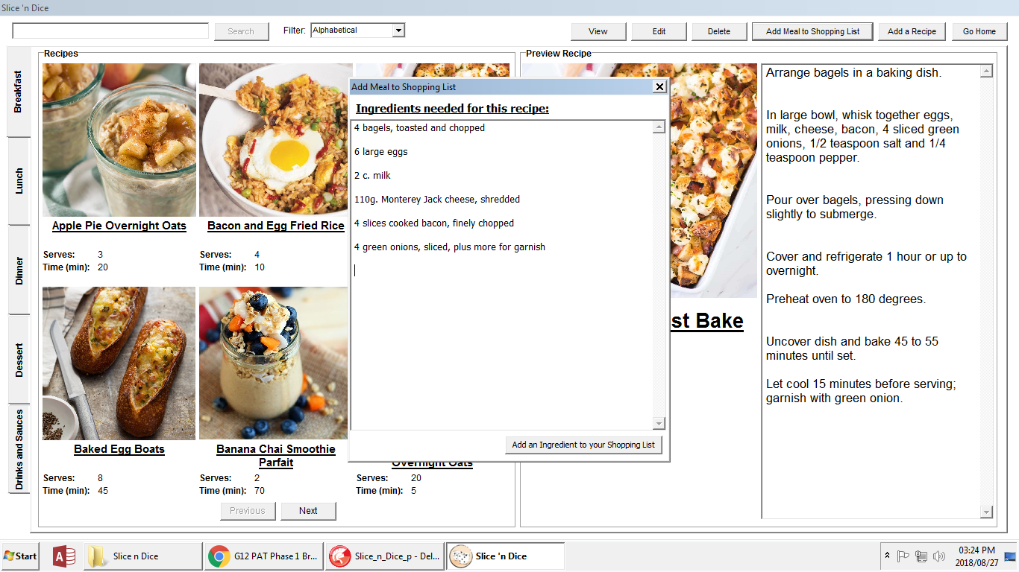

|  |  |  |
| --- | --- | --- |
| **INPUT** | **PROCESS** | **OUTPUT** |
| “Add Ingredient to Shopping List” button is clicked | Calls ingredient adding to shopping list procedure from home screen | Shopping list is updated |

## Viewing a Recipe

### Slice_n_Dice_View_u - SelectedRecipe

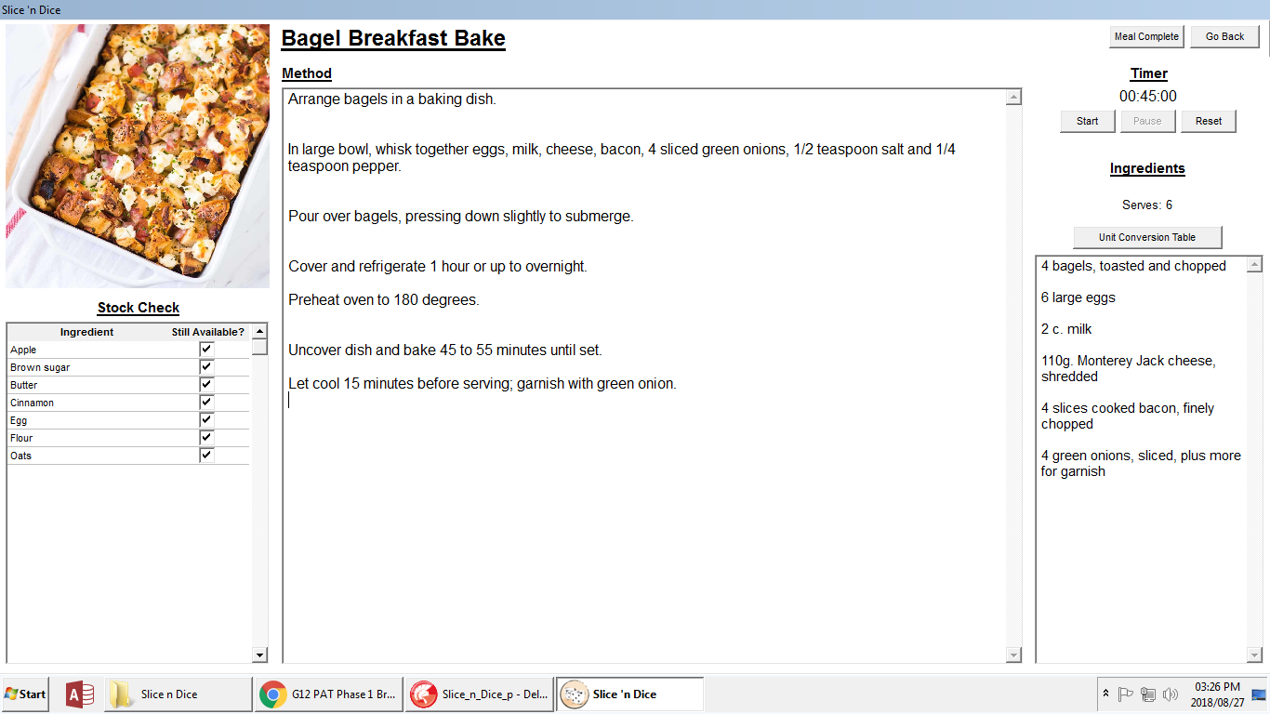

|  |  |  |
| --- | --- | --- |
| **INPUT** | **PROCESS** | **OUTPUT** |
| User clicks “Start” button | Timer component is enabled | Timer displayed to user is updated based on timer component |
| User clicks “Stop” button | Timer component is disabled | Timer displayed to user is frozen based on timer component |
| User clicks “Reset” button | Timer component is updated with new timer interval | Timer displayed to user is updated based on timer component |
| User clicks “Unit Conversion Table” button | “Unit Conversion Table” form is created | “Unit Conversion Table” is shown to user as pop up |
| User clicks “Meal Complete” button | Current date and meal name is logged | “View” form is closed and data is logged in database |

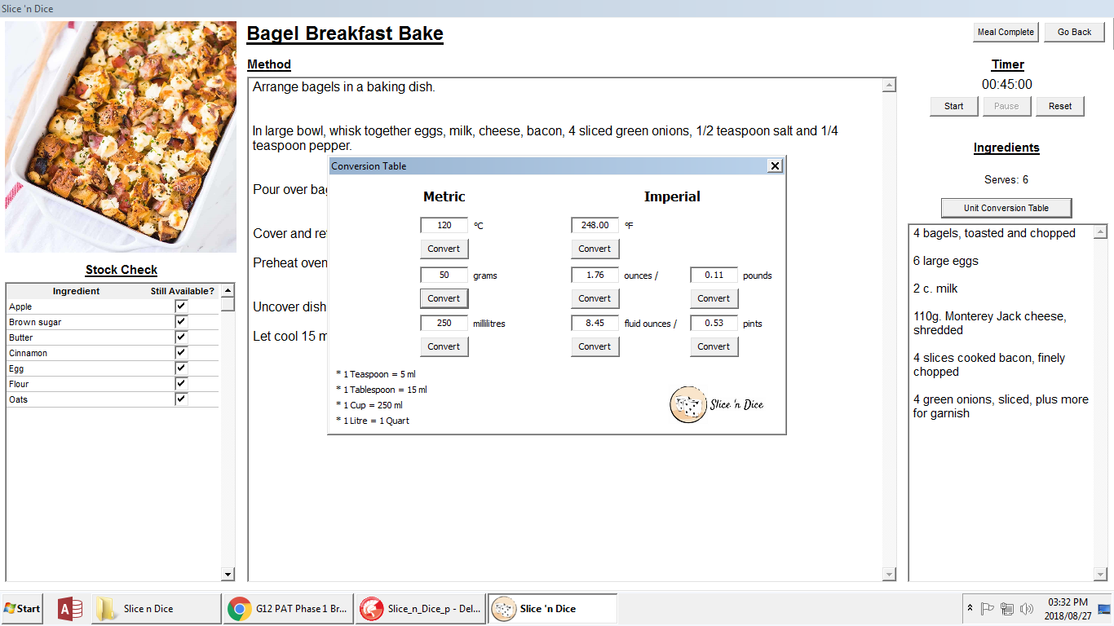

|  |  |  |
| --- | --- | --- |
| **INPUT** | **PROCESS** | **OUTPUT** |
| “Convert” button is clicked | Math is done to calculate new value in imperial or metric form depending on which was entered by user | Imperial or metric unit is updated based on user’s entered data to convert |

## Adding or Editing a Recipe

### Slice_n_Dice_Add_OR_Edit_u - AddOREditRecipe

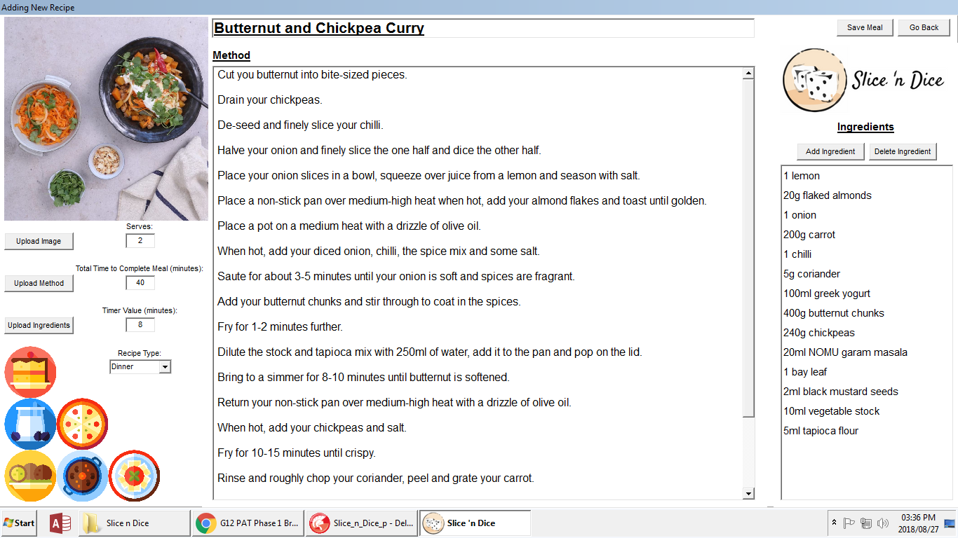

The same form is used for adding or editing a recipe. The application knows whether the user is adding or editing a recipe from the objDependencies. If the user is editing a recipe, the add form has the fields filled in with the appropriate data from the database.

|  |  |  |
| --- | --- | --- |
| **INPUT** | **PROCESS** | **OUTPUT** |
| User clicks on any of the “Upload” buttons | Upload dialogs are created and displayed for user to select appropriate files | Appropriate file is uploaded to form application |
| “Add Ingredient” button is clicked | Dialog’s displayed for user to enter new ingredient text | New ingredient text is added to the end of the ingredient listbox |
| “Delete Ingredient” button is clicked | Listbox finds which item is selected to be deleted, then the item(s) is/are deleted | Ingredient listbox is updated with appropriate data |
| “Save Meal” button is clicked | Data in this application form is written to the database to either update, insert or delete values that are in the database | User is shown dialog to tell them that the meal has been saved and the form closes |
| “Go Back” button is clicked | User confirmation about going back and that doing so discards all written data | Form is either closed and data is discarded or form remains open |

## Inventory

### Slice_n_Dice_Inventory_u - SnDInventory

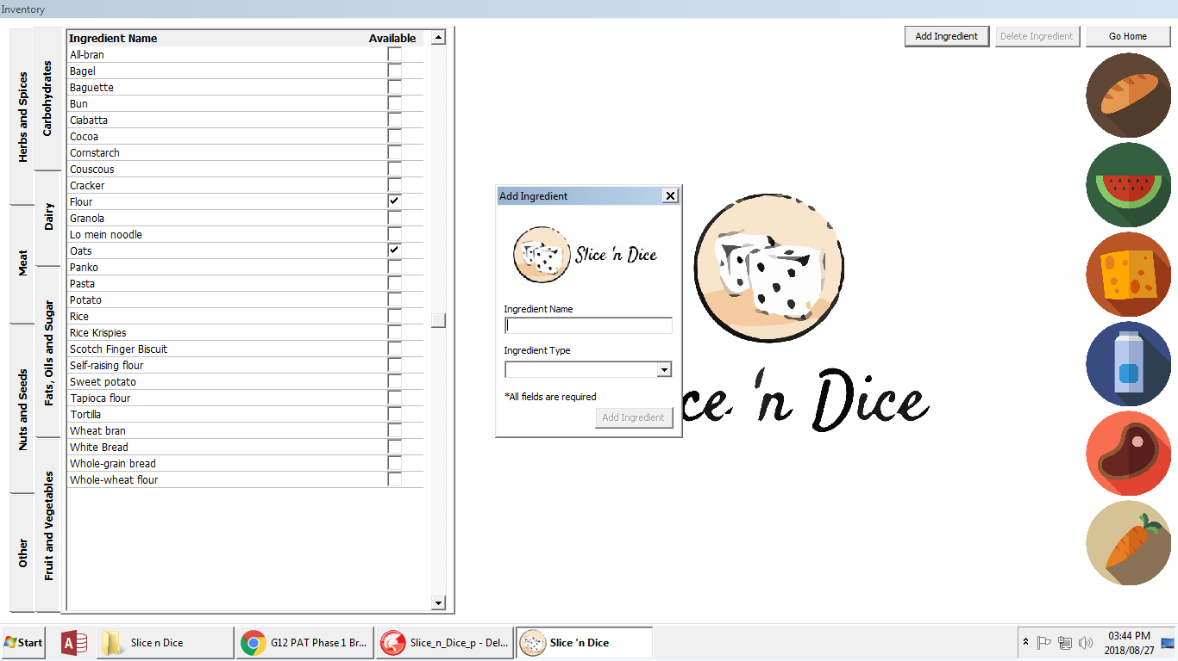

|  |  |  |
| --- | --- | --- |
| **INPUT** | **PROCESS** | **OUTPUT** |
| User changes tab on tab control | Database is re-filtered based on tab index | Ingredient data displayed is updated based on filter |
| User selects the “Available” checkbox | Check if ingredient is set as available or unavailable | Change value in application and database to opposite of what it was |
| “Add Ingredient” button is clicked | Create “Add Ingredient” form | “Add Ingredient” form is displayed |
| Both fields have data entered and user clicks the “Add Ingredient” button | Database is updated with new ingredient | Application is refreshed to display newly added ingredient; fields are cleared for user to enter another new ingredient |
| “Delete Ingredient” button clicked | Check what ingredient is selected and find it in the database to delete it | Delete the selected ingredient and update the values shown in the application |

## Analytics

### Slice_n_Dice_Analytics_u - SnDAnalytics

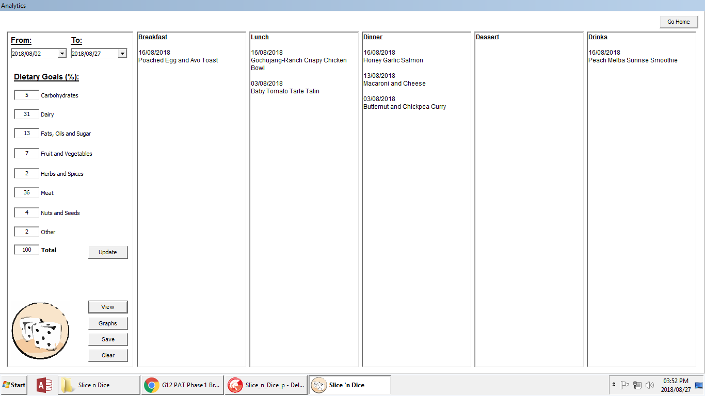

|  |  |  |
| --- | --- | --- |
| **INPUT** | **PROCESS** | **OUTPUT** |
| User select “to” and “from” date | Checks if valid, logical dates are selected | Functions are enabled or disabled based on if logical dates were selected by the user |
| User changes values in the “Dietary Goal” section | Adds values in the input fields | “Total” field is updated to show current “Dietary Goal” count |
| “Update” button is clicked | Dietary goal values are updated in database and array | Pop up confirms with user about the updated values |
| “View” button is clicked | Goes through database checking for values which lie in the “to” and “from” dates selected by the user | Columns on the right are updated with recipe names based on “to” and “from” dates |
| “Save” button is clicked | Loads the data in columns into a text file to be saved | Confirms with user about text file save |

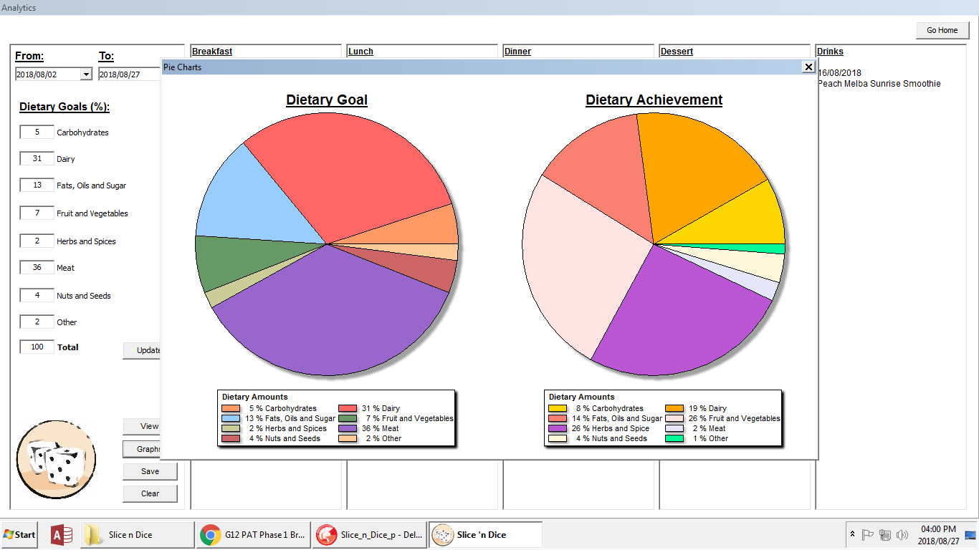

|  |  |  |
| --- | --- | --- |
| **INPUT** | **PROCESS** | **OUTPUT** |
| User views graphs by clicking “Graphs” button | Goes through database to search for appropriate values and updates array of ingredient type which counts the amount of an ingredient type used in creating the pie chart “Dietary Achievement”. “Dietary Goal” pie chart gets values directly from a table in the database | Pie charts are displayed with appropriate values |